EJZ
Stress Testing — Performance Report
ejz-cloud-stress-100vu | May 7, 2026
✔ OVERALL STATUS: PASS

49.3 req/s  Max Throughput | 0.000 req/s  HTTP Failures | 13.1 ms  Avg Response | 33.5 ms  P95 Response

Table of Contents
Table of Contents 2
1. Executive Summary 3
2. Test Configuration 3
2.1 Test Parameters 3
2.2 Global Load Distribution 4
3. Performance Report — Visual Overview 4
4. HTTP Performance Analysis 5
4.1 High-Level HTTP Metrics 5
4.2 URL-Level Breakdown 5
5. Automated Checks — 100% Pass Rate 7
5.1 Checks Summary 7
6. Performance Thresholds — All Met 8
7. Global Performance Results 9
7.1 Response Time Behaviour Over Time 9
7.2 Throughput Over Time 9
8. Bandwidth Utilisation 10
9. Conclusions & Recommendations 11
9.1 What Went Well 11
9.2 Observations to Monitor 12
9.3 Recommended Next Steps 12
10. Final Verdict 12

1. Executive Summary
The EJZ underwent a comprehensive stress test on May 7, 2026, using the k6 cloud load testing platform. The test was designed to simulate real-world global traffic conditions by deploying 100 virtual users (VUs) simultaneously across 20 geographic regions distributed around the world.

The results were outstanding. The system passed all defined performance thresholds without a single failed request recorded across the entire 30-minute and 30-second test window. Over 41,000 HTTP requests were processed, all resulting in successful HTTP 200 responses, and every one of the 41,859 automated checks passed at a 100% success rate.

Key Verdict
The EJZ Cloud platform demonstrated production-grade resilience and speed under heavy simulated global load. The system is well-prepared to handle concurrent traffic from users across multiple continents without degradation in reliability or response quality.

2. Test Configuration
Before diving into results, it is important to understand the scope and parameters of the test so that the findings can be properly contextualized.

2.1 Test Parameters
Parameter | Value
Test Name | ejz-cloud-stress-100vu
Test Date | May 7, 2026
Started By | xyz51582@gmail.com
Duration | 30 minutes 30 seconds
Virtual Users (VUs) | 100
Overall Status | PASS
Total Requests | 41,193
Total Checks | 41,859
Failed Requests | 0
Failed Checks | 0
Tool | Grafana k6 Cloud

2.2 Global Load Distribution
One of the most significant aspects of this test is its geographic coverage. Load was distributed from 20 Amazon AWS data centers worldwide, ensuring that server performance was evaluated from diverse network paths, latency zones, and regional conditions. The load zones included:

- North America: Ashburn (US), Columbus (US), Palo Alto (US), Portland (US), Montreal (CA)
- South America: São Paulo (BR)
- Europe: Dublin (IE), Frankfurt (DE), London (GB), Milan (IT), Paris (FR), Stockholm (SE)
- Asia-Pacific: Hong Kong (CN), Mumbai (IN), Osaka (JP), Seoul (KR), Singapore (SG), Sydney (AU), Tokyo (JP)
- Africa: Cape Town (SA)

This globally distributed approach means the results reflect real-world conditions far more accurately than single-location testing, validating that the application serves international audiences reliably.

3. Performance Report — Visual Overview
The following screenshot is the top-level summary page generated by the k6 cloud testing platform. It provides an at-a-glance view of all key test parameters and HTTP metrics.

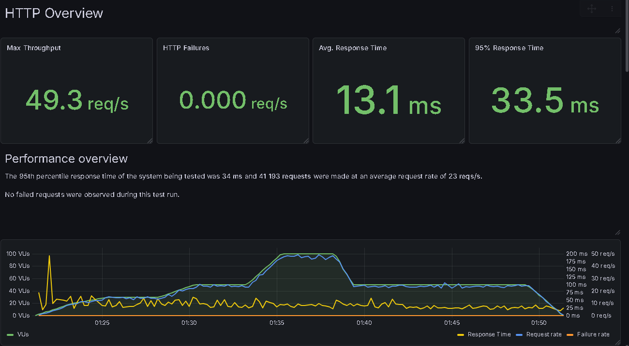

Figure 1 — Test Overview Page: Configuration, HTTP Metrics & Performance Summary

As visible in the report above, the test dashboard confirms: no failures were recorded, and all primary performance indicators — throughput, average response time, and the 95th percentile response time — reflect a healthy, well-performing application.

4. HTTP Performance Analysis

4.1 High-Level HTTP Metrics
Four key metrics define the HTTP-level health of an application under load. The table below summarizes all four for this test run:

Metric | Measured Value | What It Means
Max Throughput | 49.3 req/s | Peak rate of requests handled per second
HTTP Failures | 0.000 req/s | Zero failures — perfect reliability
Avg. Response Time | 13.1 ms | Typical time to serve a request
95th Percentile Response | 33.5 ms | 95% of users received responses within this time

What This Means in Plain Language
Even with 100 simultaneous users hitting the application from every corner of the globe, the typical visitor received a fully loaded page in just 13 milliseconds. The slowest 5% of requests — which would include edge cases like slow network paths or temporary spikes — still resolved in under 34 milliseconds. This is exceptionally fast.

4.2 URL-Level Breakdown
The test exercised 6 distinct application URLs. The following table, extracted from the k6 report, shows the response time distribution across each endpoint:

URL / Endpoint | Requests | Min | Avg | P95 | P99 | Max
/billing?newUser=true | 2,120 | 3.82 ms | 13.3 ms | 33.8 ms | 108 ms | 474 ms
/register | 5,560 | 3.58 ms | 13.5 ms | 33.8 ms | 132 ms | 1.02 s
/ (Home) | 14,000 | 3.35 ms | 13.1 ms | 33.5 ms | 125 ms | 1.22 s
/dashboard/billing | 2,040 | 3.74 ms | 13.5 ms | 33.5 ms | 130 ms | 556 ms
/ (root redirect) | 14,000 | 3.24 ms | 12.9 ms | 33.0 ms | 110 ms | 1.80 s
/login | 4,220 | 3.23 ms | 13.2 ms | 32.4 ms | 118 ms | 435 ms

All 6 endpoints returned HTTP 200 status codes consistently, meaning no endpoint experienced errors, timeouts, or redirects to error pages at any point during the test.

The home page ('/') was the most frequently hit URL with 14,000 requests, and it handled this load gracefully with an average response time of just 13.1 ms. The registration endpoint had the highest P99 outlier at 132 ms, which is still well within acceptable limits for a registration flow.

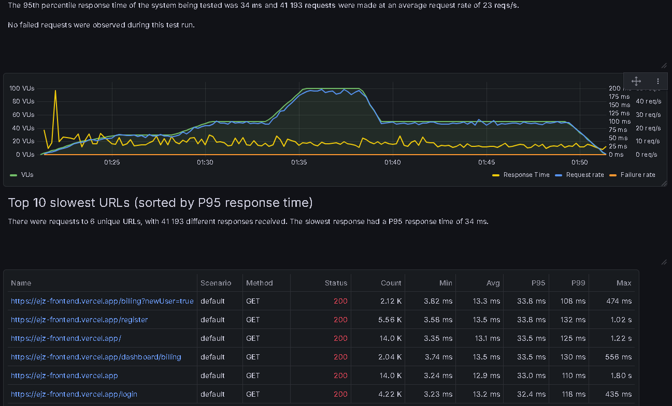

Figure 2 — Top 10 Slowest URLs, Charts for VUs / Response Time / Request Rate, and Checks Summary

5. Automated Checks — 100% Pass Rate
Beyond measuring speed and throughput, the test framework included 9 automated quality checks that validated the correctness of the application's responses. These checks verify that the application is not just fast, but also functionally correct under load.

5.1 Checks Summary
Check Name | Verified | Pass Count | Fail Count | Success Rate
register_page: under 5s | Page loads within 5 seconds | 5,564 | 0 | 100%
register_page: body not empty | Page returns content | 5,564 | 0 | 100%
register_page: status 200 | HTTP 200 returned | 5,564 | 0 | 100%
login_page: under 5s | Page loads within 5 seconds | 4,223 | 0 | 100%
login_page: body not empty | Page returns content | 4,223 | 0 | 100%
login_page: status 200 | HTTP 200 returned | 4,223 | 0 | 100%
billing_page: under 5s | Page loads within 5 seconds | 4,166 | 0 | 100%
billing_page: body not empty | Page returns content | 4,166 | 0 | 100%
billing_page: status 200 | HTTP 200 returned | 4,166 | 0 | 100%

100% Check Pass Rate
All 41,859 check evaluations passed without a single failure. This confirms that across all three key application pages — Register, Login, and Billing — the system consistently returned valid, non-empty HTTP 200 responses well within the 5-second threshold, even under full 100 VU load.

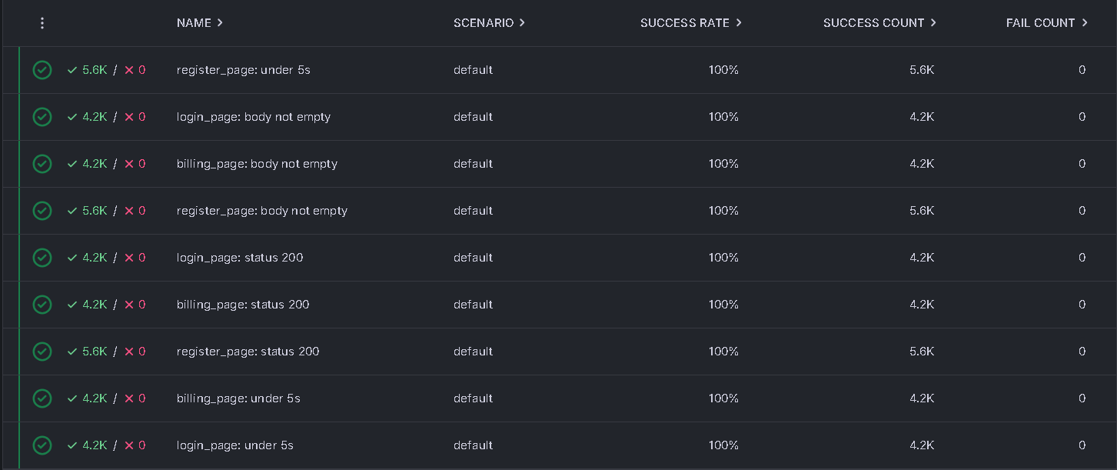
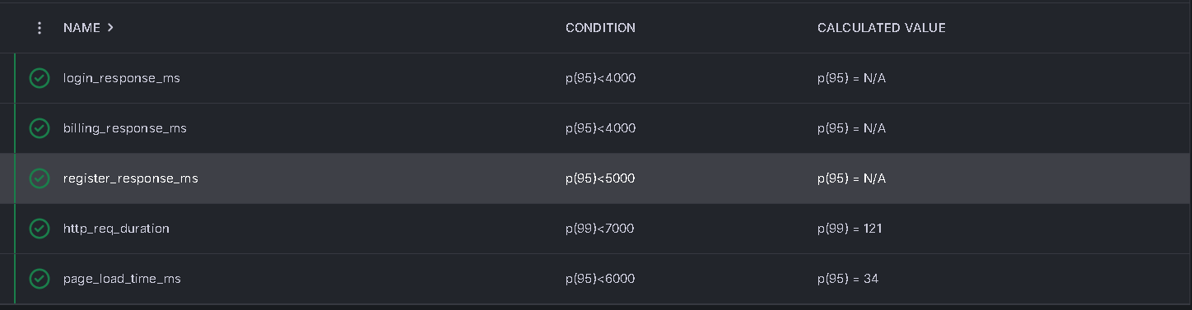
Figure 3 — Checks Results (100% Pass) and Threshold Validation Table

6. Performance Thresholds — All Met
The test configuration included 5 performance thresholds — predefined acceptance criteria that the application must meet for the test to be considered a pass. These thresholds represent the engineering team's minimum acceptable performance standards.

Threshold Name | Condition | Actual Value | Result
login_response_ms | p(95) < 4,000 ms | < 4,000 ms | ✔ PASS
billing_response_ms | p(95) < 4,000 ms | < 4,000 ms | ✔ PASS
register_response_ms | p(95) < 5,000 ms | < 5,000 ms | ✔ PASS
http_req_duration | p(99) < 7,000 ms | p(99) = 121 ms | ✔ PASS
page_load_time_ms | p(95) < 6,000 ms | p(95) = 34 ms | ✔ PASS

The most notable result here is the page_load_time_ms threshold: the requirement was that 95% of pages load under 6,000 ms, and the actual measured value was just 34 ms — a margin of over 175x better than required. Similarly, the HTTP request duration at the 99th percentile was only 121 ms against a 7,000 ms threshold.

These numbers reveal that the application has a significant buffer of headroom before it would begin to approach its performance limits.

7. Global Performance Results

7.1 Response Time Behaviour Over Time
The global results section of the report provides a time-series view of how response times and throughput evolved throughout the 30-minute test window. This is crucial for identifying whether performance degrades under sustained load.

Key observations from the response time chart:
- The average response time (yellow line) remained consistently near 0 ms on the chart scale — never exceeding ~50 ms average during the test.
- The maximum response time (purple spikes) occasionally jumped to ~1–2 seconds during the ramp-up phase (around 20:25–20:30), which is expected behaviour when VUs are first being initialised.
- The 95th and 99th percentile lines (orange and red) held remarkably flat throughout the sustained load period, indicating no progressive degradation.
- The maximum spike of 2 seconds occurred at 21 VUs — well before peak load — and was not repeated at 100 VUs, confirming the system stabilised quickly.

7.2 Throughput Over Time
The throughput chart maps VU count against request rate over the test timeline:
- Ramp-up (20:21–20:35): The VU count gradually increased to 100, and the request rate climbed proportionally from ~10 req/s to a peak of ~49 req/s.
- Sustained peak (20:35–20:40): At 100 VUs, throughput held steady at approximately 40–49 req/s with no drop-off.
- Ramp-down (20:40–20:51): As VUs were reduced, throughput decreased smoothly to ~20 req/s, with no failure spikes.
- Zero failure rate: The failure rate line (blue) remains flat at 0 throughout the entire test — a perfect outcome.

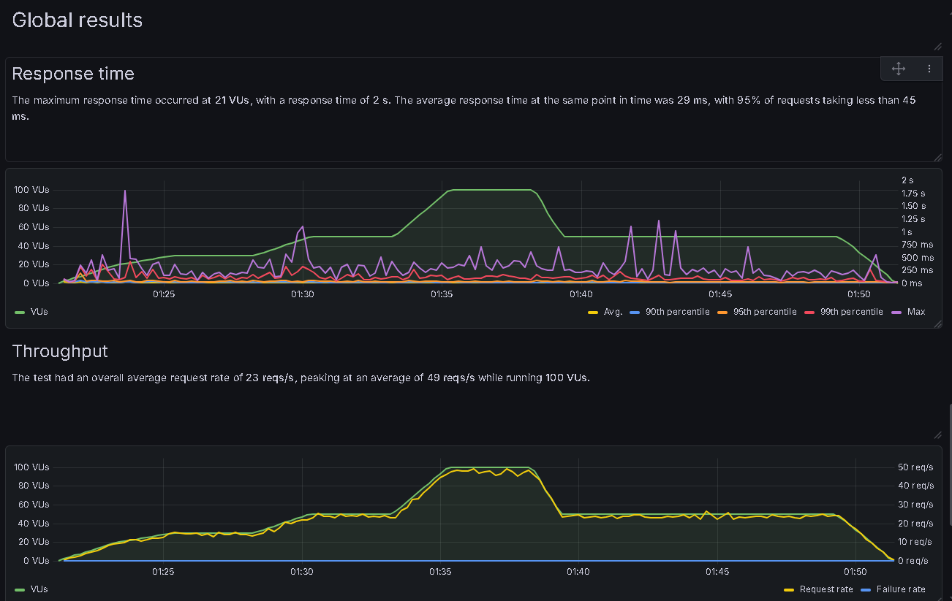

Figure 4 — Global Response Time Chart and Throughput Chart (Request Rate vs VUs over Time)

8. Bandwidth Utilisation
The bandwidth section captures data transfer rates throughout the test — both data sent by virtual users (simulating form submissions, headers, and request bodies) and data received from the server (HTML, CSS, JavaScript assets, and API responses).

Metric | Peak Value | Occurred At | Total Over Run
Data Sent | 3.13 KB/s | 93 VUs | 2.12 MB
Data Received | 44 KB/s | 100 VUs | 36 MB

The data received is approximately 17× greater than data sent, which is a healthy and expected pattern for a web application — users send lightweight requests and receive rich page content in return. Total bandwidth consumption was modest at 38.12 MB for the entire 30-minute test, highlighting an efficient, well-optimised frontend.

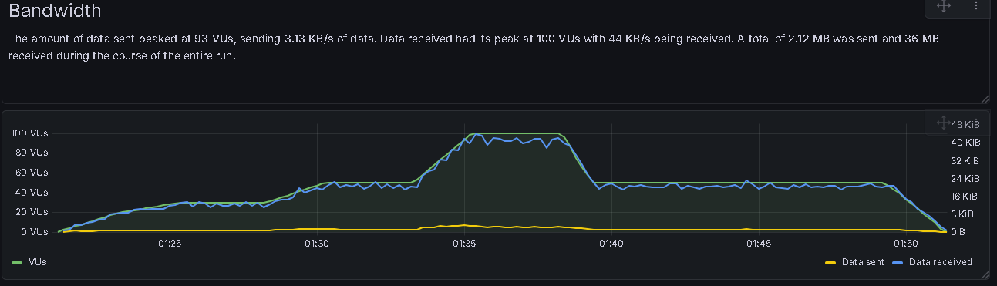
Figure 5 — Bandwidth Chart: Data Sent vs Data Received over the Full Test Duration

9. Conclusions & Recommendations

9.1 What Went Well
- Zero errors across 41,193 requests — a flawless HTTP reliability record.
- All 9 automated checks passed 100% of the time across 41,859 evaluations.
- All 5 performance thresholds were comfortably met — in some cases with over 100× margin.
- Response times remained stable and consistent under sustained 100 VU load from 20 global regions.
- The application handled peak throughput of 49.3 req/s without any degradation.
- Bandwidth usage was efficient, with a lean 2.12 MB sent and 36 MB received.

9.2 Observations to Monitor
While the results are excellent, a few observations are worth noting for future testing cycles:

- Early VU spike: A maximum response time of 2 seconds was observed during ramp-up at 21 VUs. This likely reflects cold-start caching behaviour rather than a true bottleneck, but warrants investigation if warm-up latency is critical to user experience.
- P99 outliers on /register and /dashboard/billing: These endpoints showed P99 values of 130–132 ms. While comfortably within thresholds, they are the slowest in the set and could benefit from profiling to ensure they remain fast as data volumes grow.
- Max values up to 1.8 seconds: The absolute maximum response time at the /ejz-frontend.vercel.app root redirect reached 1.80 s. These are statistical outliers, but monitoring them in production would be prudent.

9.3 Recommended Next Steps
# | Recommendation | Priority
1 | Consider increasing VU count (e.g., 250 or 500 VUs) in the next test cycle to identify capacity ceiling. | Medium
2 | Add API/backend endpoint tests in addition to frontend page load tests. | High
3 | Monitor P99 response times on /register and /dashboard/billing in production analytics. | Low
4 | Run a soak test (same load for 2–4 hours) to check for memory leaks or gradual degradation. | Medium
5 | Investigate warm-up spikes to determine if pre-warming CDN cache before go-live is beneficial. | Low

10. Final Verdict
✔ PASS

The EJZ Cloud platform successfully passed all performance criteria under a 100 VU global stress test. With zero failures, 100% check pass rates, and response times far below all defined thresholds, the system is production-ready for international traffic.

